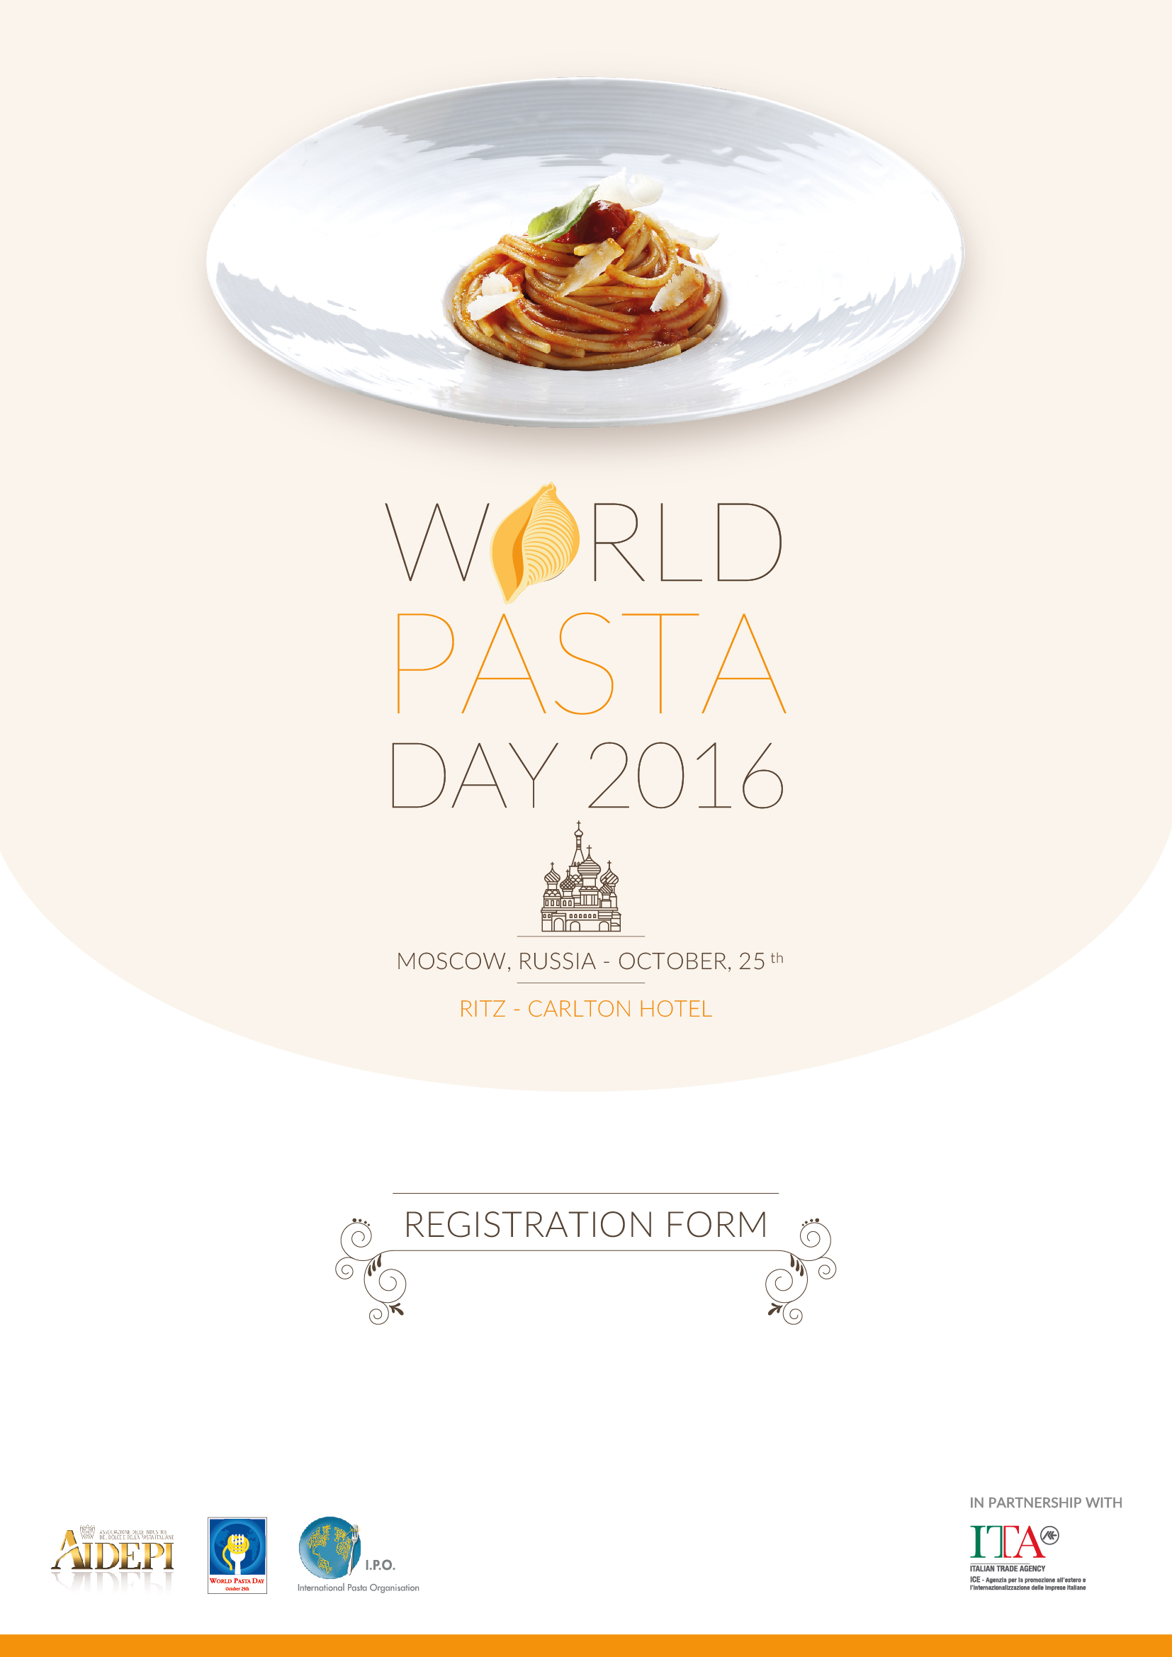
World Pasta Day 2016 and IPO Annual General Assembly
Moscow, 24 - 25 October 2016

REGISTRATION FORM

Name and Surname:
Firm/Organisation:
Address:
Tel:
Fax:
E-mail:

(Please mark the events you are planning to attend) | YES | NO
World Pasta Day Conference – 25 October 2016
"Pasta: the perfect choice for a tasty, healthy and sustainable diet"
International Pasta Organisation IPO
Annual General Assembly

Please return this form not later than August 31st, 2016 to:

IPO, Francesca Ronca E-mail: f.ronca@internationalpasta.org

